ICC Europe Division 2 Guernsey 2010
Guernsey v Norway
Played at King George V on 19th July 2010 in European Division 2
Guernsey Won by 109 runs
Toss won by Guernsey who elected to bat
Umpires T Jensen (Denmark) and K Smith (Ireland)

MATCH
Cricket Europe article:
Guernsey duly completed a clean sweep winning their fifth game of the ICC Europe Division Two Championship by comprehensively beating Norway by 109 runs at KGV.
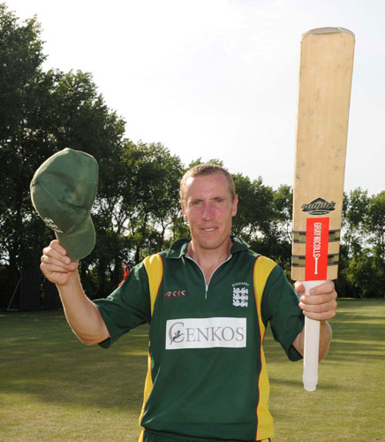
Jeremy Frith acknowledges the applause for his century ICC/CricketEurope
Their total of 219 was dominated by two individual performances – Jeremy Frith scored his second century of the tournament, while skipper Stuart Le Prevost made 53. Frith scored 109 from just 107 balls, striking 13 fours and three sixes, as he shared in a match winning stand of 131 with Le Prevost. The stand took 140 balls, with Le Prevost’s 53 occupying 77 deliveries. At 186 for 3 with 14 overs remaining, a total of 280 looked on the cards, but a dramatic collapse saw them lose seven wickets for 33 runs. Aamir Waheed (3-35), Shahbaz Butt (3-37), and Aram Dawood (2-22) were best with the ball for Norway.
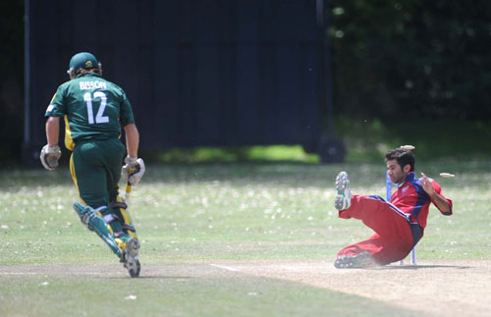
Stuart Bisson run out ICC/CricketEurope

Andy Hutchinson and Stuart Bisson ‘high-five’ after claiming a wicket ICC/CricketEurope
Any thoughts that the batting failures could have been costly were quickly dispelled as Lee Savident (3-8) ripped through the Norwegian top order to leave them reeling at 29 for 4. A fifth wicket stand of 57 between Will Barton (51) and Shahbaz Butt (23) gave Norway some hope, before the spin combination of Gary Rich (4-22) and Jeremy Frith (2-22) saw them dismissed for 110 in 38.1 overs.
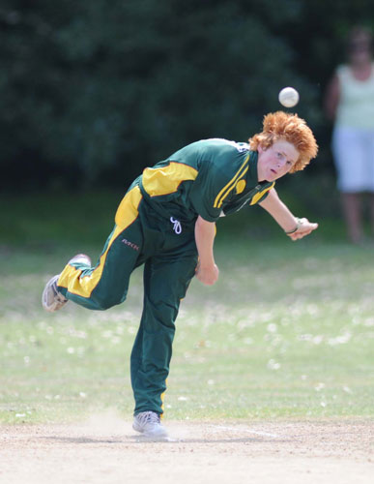
David Hooper in action ICC/CricketEurope
A much deserved win for Guernsey who played the most consistent cricket all week.
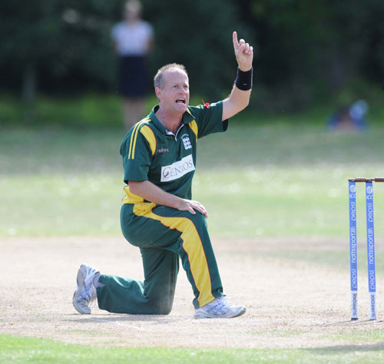
Gary Rich appeals and another one bites the dust ICC/CricketEurope
Stats:
Jeremy Frith hit the 2nd highest score of 120 v Norway and the 3rd highest score with 109 v Germany. Lee Savident hit the 4th highest with 100* against Gibraltar. Needless to say Jeremy Frith was easily first in the aggregate runs with 306.
Jeremy Frith also finished 1st in the bowling with 12 wickets, and Gary Rich came 2nd with 10 wickets. In the best bowling performance Gary Rich came 3rd with 4 for 22 against Norway.
In partnerships Frith and Savident scored 100 v Gibraltar, Frith and Tim Ravenscroft scored 133* v Germany and Frith together with Stu Le Prevost scored 131 v Norway.

