ICC Europe Division 2 Guernsey 2010
Guernsey v Germany
at College Field, Guernsey on Thursday 16th July 2010
ICC European Championship Division Two
Guernsey beat Germany by 8 wickets
Guernsey won the toss who elected to field
Match Referee R Holyer
Umpires B Hartong (Netherlands, D Bray (Guernsey) (3rd: A Neill – Ireland)

Match Notes Frith 50 in 74 balls, 4 fours. Ravenscroft 50 in 53 balls, 6 fours. Frith 100 in 127 balls 8 fours.
MATCH
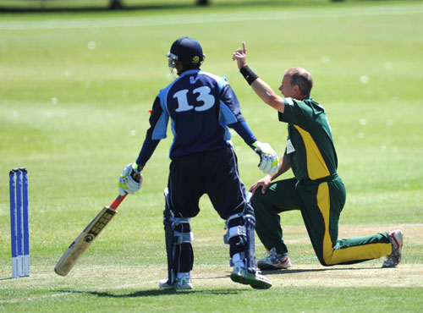
Gary Rich in familiar pose ICC/CricketEurope
Press ‘Frith in top form’
A SUBLIME hundred by Jeremy Frith guided Guernsey to a comfortable victory over Germany at the College Field on Friday. The win, their third in succession, was achieved with a 133-run unbroken partnership between Frith, who finished on exactly 100, and Tim Ravenscroft, who hit a classy 64. The job had already been half done by another impressive Sarnian bowling display, restricting the visitors to 188 from their 50 overs. At first, that looked like being much more, as Milan Fernando displayed some powerful hitting at the top of the order.
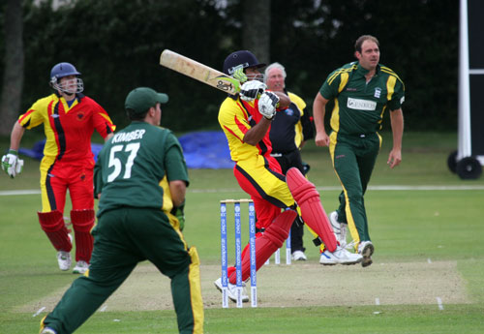
Fernando hooks Lee Savident ICC/CricketEurope
But once Lee Savident removed him for 32, Germany slowed their pace incredibly, mainly due to some accurate bowling from Savident, Jonny Warr and the spin of Frith. Indeed, it was a fine all-round display by Frith, who picked up three wickets.
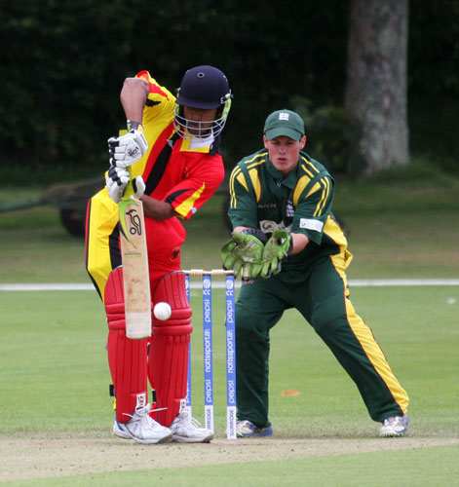
Tom Kimber ICC/CricketEurope
A slight surge by the Germans at the end of their innings at least gave them sniff, but they knew that early wickets were key in Guernsey’s chase. To their credit they did just that. Savident and Blane Queripel fell leaving the score at 57 for two, but Frith and Ravenscroft ensured smooth passage. Frith got his century, which included one particularly stunning cover drive, off the penultimate ball, leaving Ravenscroft to win the match for his side. It was particularly pleasing as Frith finally got the European ton that had deserted him despite his World Cricket League brilliance, while Ravenscroft finally looked the real deal in a Guernsey shirt.
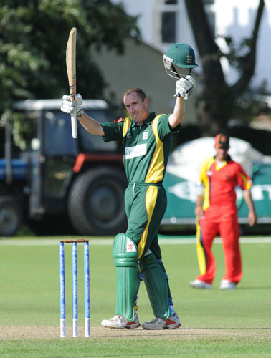
Jeremy Frith celebrates his hundred ICC/CricketEurope
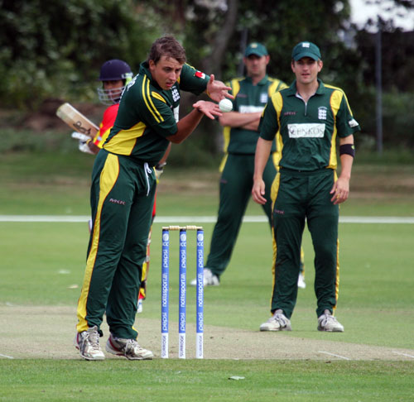
JJ Warr takes a return from the outfield ICC/CricketEurope
Cricket Europe article:
Jeremy Frith put in a fine all-round performance as Guernsey moved a step closer to the European Division Two title at College Field today.
Guernsey captain Stuart Le Prevost won the toss on a sunny morning and didn’t hesitate to put Germany in on what looked to be a bowler’s wicket. Germany started well though with Milan Fernando hitting a quick-fire 32 from just 30 balls before Savident removed him. Savident also removed the other opener and bowled his ten overs straight through to finish with 2-25. Jonathan Warr also bowled his overs straight through to finish with 0-25 with Germany having scored 50 from their first 20 overs. Jeremy Frith then took 3-37 to help reduce Germany to 123-6. An unbroken seventh wicket partnership of 65, interrupted by a brief rain shower, helped Germany recover to post 188-6 from their 50 overs.
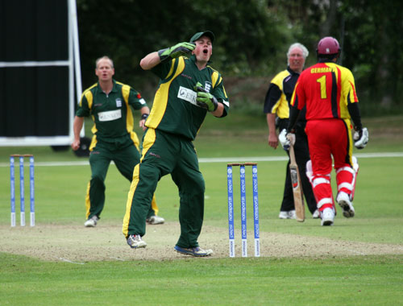
Ouch! – Tom Kimber catches one on the end of his fingers ICC/CricketEurope
In their reply, Guernsey lost both openers for just nine, with the score on 57, by which time Jeremy Frith was already going well. He was joined by Tim Ravenscroft, who recently signed a development contract with Sussex, and the pair put on an unbeaten 133 for the second wicket.
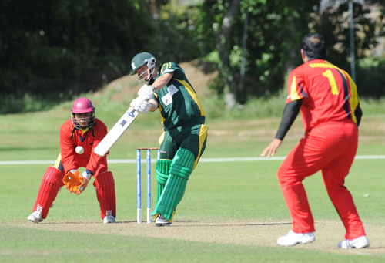
Tim Ravenscroft on his way to 50 ICC/CricketEurope
Jeremy Frith, who along with Ravenscroft was running very well between the wickets, hit three to bring up his century, and three balls later Ravenscroft hit a four to end the match and secure a two wicket win for Guernsey.
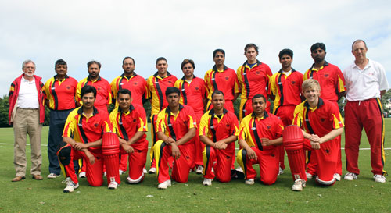
German team ICC/CricketEurope
Guernsey will play France tomorrow, whilst Germany will play Norway. Israel and Guernsey will also play in a battle of the two teams without a win.

