ICC Europe Division 2 Guernsey 2010
Guernsey v Gibraltar
ICC European Championship Division Two
at KGV, Castel, Guernsey on Tuesday 13th July 2010 (50 over match)
Toss won by Guernsey who elected to bat
Result Guernsey won by 141 runs
Umpires A Dowdalls, A Neill (3rd: B Hartong)
Scorers S Veillard, T Finlayson

MATCH
‘Ruthless Guernsey see off Gibraltar in clinical fashion’ by Matt Lihou
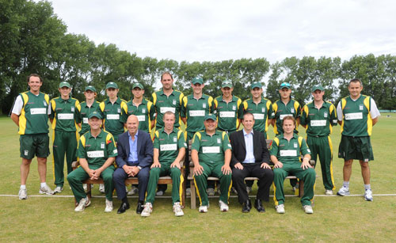
Guernsey squad prior to the match against Gibraltar ICC/CrickcetEurope
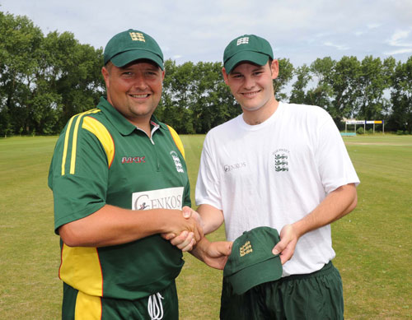
Jamie Nussbaumer receives his Guernsey ‘cap’ before the match from captain Stuart Le Prevost ICC/CricketEurope
CLINICAL.
That would be the best word to describe Guernsey’s first win of this year’s ICC European Division Two Championship against Gibraltar yesterday. Andy Cornford’s men were not at their supreme best but, in truth, they never needed to be to overcome a side who were mediocre at best. After only narrowly beating the same opponents two years ago, Guernsey would really have expected a much sterner test of their title credentials. But all hope had disappeared for the visitors within 10 overs of their batting reply, when they had been reduced to nine for three.
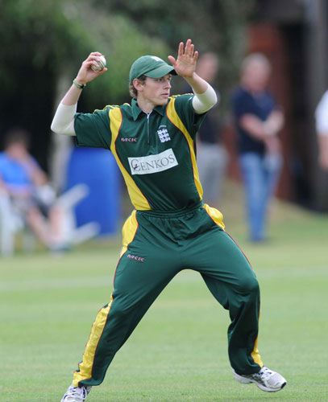
Classic action from Ben Ferbrache in the field ICC/CricketEurope
It had started off much brighter, however, as they reduced Stuart Le Prevost’s home side to two for one – Ross Kneller falling first ball after his captain won the toss and decided to bat. But that brought Jeremy Frith to the crease, the man who has hit three World Cricket League centuries in his career. He and Lee Savident, arguably Guernsey’s two finest batsmen, were soon into their stride and accumulating runs at a healthy pace. By the time Frith had departed after an unfortunate run out for 51, his side were well placed at 102 for two from 25 overs.
From ball one, the emphasis of the innings had been clear – score steadily, keep wickets in hand, and start to hit the ball out of the park in the later overs. That is the role that young star Tim Ravenscroft would certainly have hoped to play, but he followed Frith back to the pavilion only moments after first leaving it, clean bowled by the tidy Kabir Mirpuri for a second-ball duck. It was another disappointment for the Elizabeth College captain, who has yet really to show his undoubted potential in a Guernsey shirt, although his side will be hopeful that changes in the coming days.
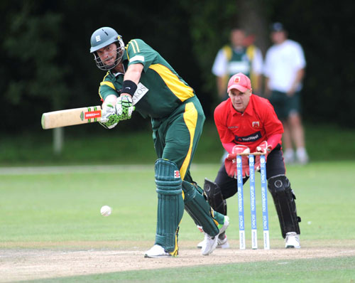
Lee Savident in determined mood ICC/CricketEurope
It did mean an extended run in the middle for captain Le Prevost. After a steady start, he was soon into his stride in an impressive partnership with Savident that yielded 86 runs at just shy of a run-a-ball. That ended when Savident was bowled for 91, playing around a straight one from Mirpuri, a shot that will have disappointed the experienced opener as he closed in on a deserved century. But that certainly did not slow the Guernsey scoring. With an impressively powerful-hitting lower order, the stage was set for an eight-over run fest. Tom Kimber duly obliged, hitting a quick-fire 42 from only 28 deliveries, which included five boundaries. Regularly finding the middle of bat, he looked in fine form, and, coupled with his flawless wicket-keeping, he was one of the stars of the show. He finished the innings alongside Le Prevost, who ended on 68 not out at nearly a run a ball in what was another fine innings.
Ultimately, that 264 would be far too difficult for Gibraltar to chase and so it proved in an 11- ball spell within the opening powerplay overs of their reply. From being nine without loss, three wickets fell without a run being added, to effectively win Guernsey the match. Debutant Andrew Hutchinson, who has had such an impressive time so far this season, picked up two wickets of his own accord, one clean bowled and the other leg-before. Fellow young opener Jonny Warr chipped in with the other and then it was purely a case of damage limitation for the visitors. And when captain Christian Rocca was run out with the score still only on 25, a three-figure score was looking only a dot on the horizon.
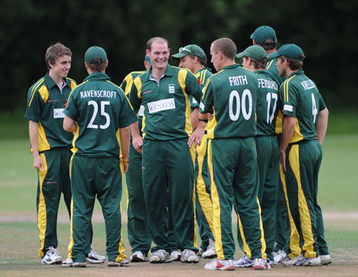
Guernsey celebrate the fall of another wicket ICC/CricketEurope
But they dug deep, realising that batting out the 50 overs would help their net run rate in the long term, making for a dull, uninteresting spectacle. Scoring at around only two an over, Guernsey struggled to make any further inroads until the 31st over, when Gibraltar’s resilience cracked. Mirpuri fell to the bowling of Ravenscroft after a fine catch by Ben Ferbrache only inches inside the boundary rope, for a painfully slow 74-ball innings of nine. Proof of the snail-like scoring was shown in Warr’s economy rate, only going for nine runs from his 10 overs, with four of those coming from a boundary. That wicket finally led to the floodgates opening and the four remaining wickets fell quickly. Ravenscroft chipped in with another; in the middle of a Frith double, while Kimber’s stumping of Christopher Watkins off Gary Rich completed the job.
The 141-run success put the home side at the top of the day one table, after both other matches had gone to thrillingly close finishes. There will no doubt be tougher tests ahead for Guernsey, perhaps as soon as today’s clash with Israel at Port Soif, but one thing was very clear. If the Sarnians can hit top form, they will take some beating.

